**Support the Regional Meeting of Tomini Bay and North Maluku Area in 2021**

By: **Cindra Zakaria**. June 2, 2021. 15:00:34

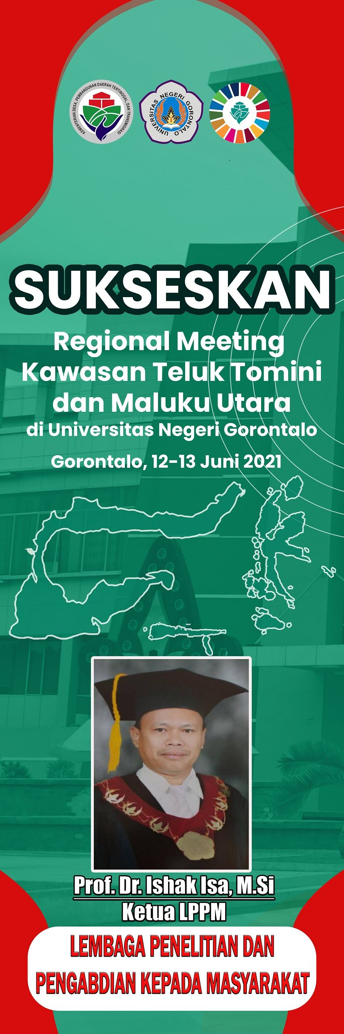

**Let’s Support the Regional Meeting of Tomini Bay and North Maluku Area**

**in Universitas Negeri Gorontalo**

**Gorontalo, from June 12 to June 13, 2021**

**Ketua LPPM: The Director of LPPM**

**The Institute for Research and Community Service**